BAR CHARTS
Pearson Edexcel - Monday 12 November 2018 - Paper 3 (Calculator) Higher Tier
1.
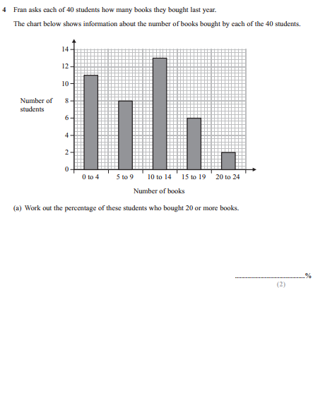
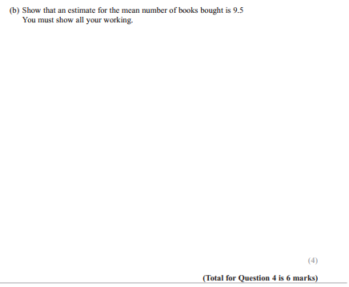
OCR GSCE – Tuesday 12 June 2018 – Paper 6 (Calculator) Higher Tier
2.
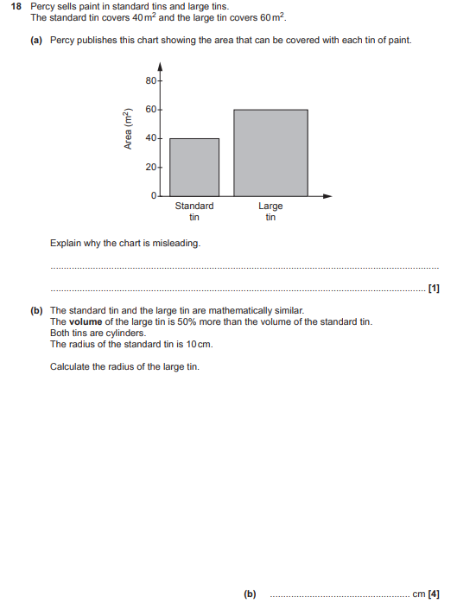

AQA GSCE – Thursday 6 November 2017 – Paper 2 (Calculator) Higher Tier
3.
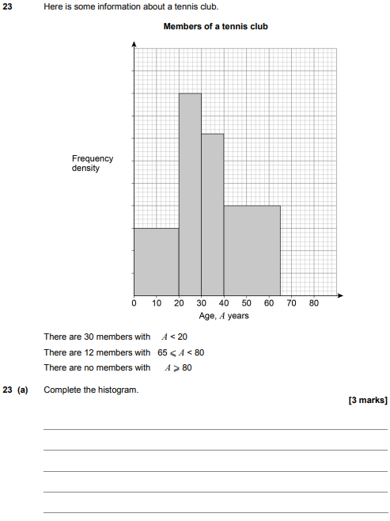
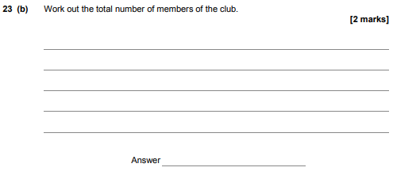
AQA GSCE – Thursday 8 June 2017 – Paper 2 (Calculator) Higher Tier
4.

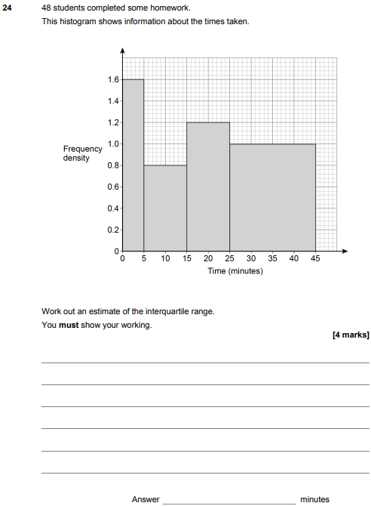

AQA GSCE – Sample Paper 2 (Calculator) Higher Tier
5.
